**Initial Identification of Skills**

**Project Description :**

As per our first meeting with Dr. Koren Ward , our supervisor for the project titled Smartphone Meter Reading System the key requirement of the project is as follows:

We are supposed to build an android application as the primary need which allows the user / customer to take the snap shots of their meters and get the readings as fast as possible. The app will consists of two version one used by the customer and another by the retailer / meter supplier.

The user model will allow the customer to use his or her smart phone to read the meter and instantly see their current consumption and billing information based on the information in the image and the billing database. Whereas the retailer version would be significantly more fast in processing image and removing all the manual work of user input like entering the address of the customer of whose meter is read, this manual input is expected to be eliminated by use of GPS technology of the cell phone by marking the address point where the meter was read and storing all the information in a efficient and secure way into the database.

This system is expected to significantly reduce the amount of work involved in reading meters.

On another the project can also be extended to development of iOS app for apple devices ranging from iPads to iPhones carrying out the same functionality. However this is the secondary need that can be achieved only if time permits.

**Skills requirement for the project :**

**Development Language to be used :** Since the project’s primary need is to have an android application the Developmentlanguage to be used is Java.

If the project development expands to the development of iOS application the development language that will be used will be Objective C and Swift.

**Platform :**  The Apllication is expected to be developed primarily for Android platform. And may be expanded to iOS platform as well.   
  
The database for the same will be accessible to user via the application or by the website via login, thus some part of the project will also be available for Web platform

**Database :** MySql

**Tools :** The tools to be used for developing the application will be as follows  
  
Android Studio : For developing Android Application

Xcode : For developing iOS applications

Adobe Photoshop : For Designing icons

**Technologies :** The key technology need for the project is the use of any image processing library, for our project we will we making use of OpenCV Image Processing library to read the analog readings from the meter along with OCR to read characters (numbers) from the meters.

Operating system :

For Android :

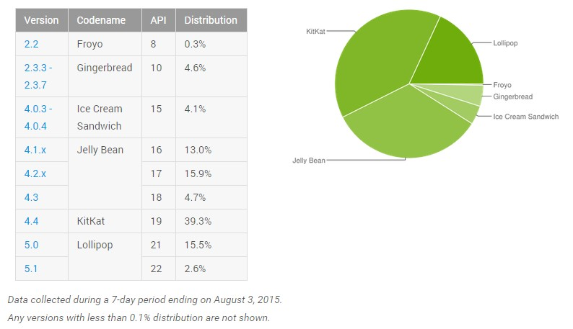

On the basis of the above mentioned statistics we aim to develop our project for all the android mobiles running Android 4.1 or above

Similarly as per the report by apple , approx. 79% iOS devices use iOS 10 followed by iOS 9 which share 16% of the market. As a result if the secondary need of the project that is development of iOS application is to be achieved we will be developing the same for iOS devices running version 8 or later

